Banking application

## Purpose

Create a custom solution for a bank application.

## Technology to use

The application will be a desktop application structured on 3 Layers:

* Database: SqlServer
* Service Layer: implemented using WCF and Entity
* UI layer: which will be a WFP application based on MVVM pattern.

## Information in the DataBase

A customer should have the following information:

* First name
* Last name
* Username
* Password
* Country
* Region
* City
* Address

Also we have information about the Account that a customer has in the bank (Notice: one customer can have more than one account)

* Account Number
* Description

## Screens To Develop:

* **Login Screen:** A customer of the bank should be able to login with his credentials, so first we need a login screen.
* **Customer Screen:** where we can
  + Load a customer: write a customer code and press the “Load” button. We can see the detail for this customer and modify any field,
  + Delete the customer that is shown on the screen
  + Create a new customer
* **Show Customer’s Account:** this screen must be a read only screen, where we can see all the bank accounts of the selected customer. (Notice: To simplify this exercise, you must enter the data in SqlServer).

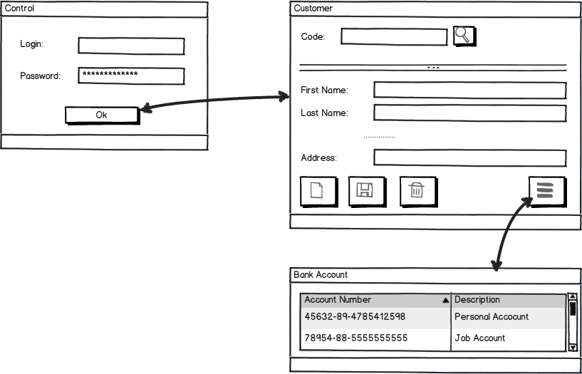

## Be careful

Our bank requires a system designed for the possibility to develop a mobile app with the same functionality, only changing the UI part.

A service oriented design is strongly recommended. All the information will be received from the server, which will call the data layer (separated from the service and from the business and client layer).